Example 2:
The following diagram represents a simplified credit card environment. There are two types of accounts: debit cards and credit cards. Credit card accounts accumulate charges with merchants. Each charge is identified by the date and amount of the charge. Transform the ER diagram into a set of relations. Be sure to identify the primary (and foreign) keys in the resulting relations.
1.Normalize
- Make weak entities strong
- CardAccount needs fk to Customer
- DebitCard needs fk
- CreditCard needs fk

- Many-to-Many relationships
- Add a charges table
- Charges: date, amount
- Review and consolidate
- charges needs fk to merchant and creditCard
NOTE: what makes the most sense to have as your pk for Charges? Makes sense that the same merchant could use the same card multiple times. Options: composite key merchant id, date,cc OR lets use a surrogate for this – makes things much less complicated.
- Charges needs pk transactionID

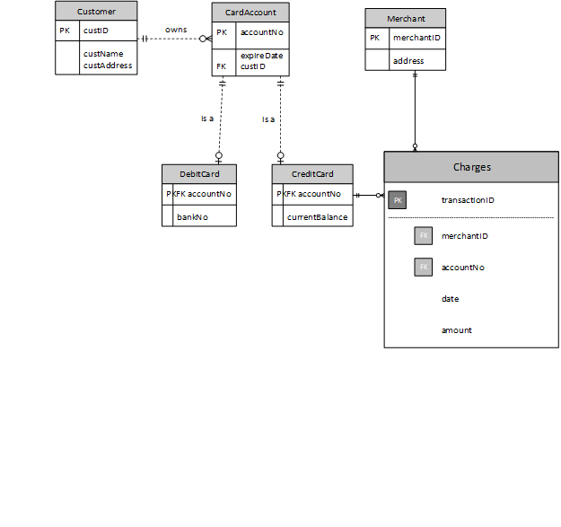
- For each entity
- Customer (custID, custFName, custLNname, custStreet, custCity, custProv, custPostalCode)
- Card Account(accountNo, expireDate, custID(fk))
- DebitCard(accountNo(fk),bankNo)
- CreditCard(accountNo(fk), currentBalance)
- Merchant(merchantID, merchName, merchStreet, merchCity, merchProv, merchPostalCode)
- Charge(transactionID, accountNo(fk), merchantID(fk), date, amount)

- For each relationship
- “is a” 1:1 Relationship
- DebitCard(accountNo(fk), bankNo)
Constraint:
- DebitCard(accountNo(fk)) references CardAccount(accountNo)
- "is a" 1:1 Relationship
- CreditCard(accountNo(fk), currentBalance)
Constraint:
- CreditCard(accountNo(fk)) references CardAccount(accountNo)
- “owns” 1:N Relationships
- CardAccount(accountNo, custID(fk), expireDate)
Constraint:
- CardCard(custID(fk)) references Customer(custID)
“has charges” N:M Relationships
- Charge(acctountNo(fk), merchantID(fk), date, amount)
- Constraint:
- Charge(accountNo(fk)) references CreditCard(accountNo)
- Charge(merchantID(fk)) references Merchant(merchantID)

3. Final schema:
- DebitCard(accountNo(fk), bankNo)
Constraint:
- DebitCard(accountNo(fk)) references CardAccount(accountNo)
- CreditCard(accountNo(fk), currentBalance)
Constraint:
- CreditCard(accountNo(fk)) references CardAccount(accountNo)
- CardAccount(accountNo, custID(fk), expireDate)
Constraint:
- CardAccount(custID(fk)) references Customer(custID)
- Charge(acctountNo(fk), merchantID(fk), date, amount)
Constraint:
- Charge(accountNo(fk)) references CreditCard(accountNo)
- Charge(merchantID(fk)) references Merchant(merchantID)
- Customer(custID, custFName, custLNname, custStreet, custCity, custProv, custPostalCode)
- Merchant(merchantID, merchStreet, merchName, merchCity, merchProv, merchPostalCode)

